Title: Sharing AMIs in AWS: A Step-by-Step Guide for Seamless Collaboration

Introduction:

In Amazon Web Services (AWS), the ability to share Amazon Machine Images (AMIs) with other AWS accounts is a valuable feature that promotes collaboration and simplifies infrastructure management. In this blog post, we will walk you through the process of sharing an AMI with another AWS account, enabling seamless teamwork and efficient resource utilization. Let's get started!

Step 1: Navigate to the EC2 Dashboard Log in to the AWS Management Console.

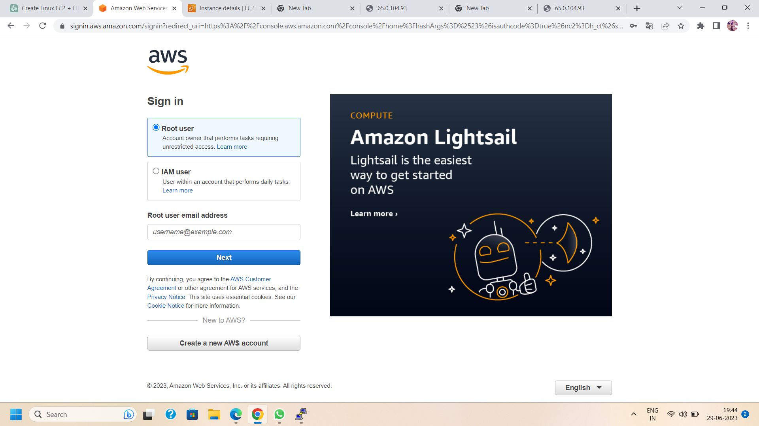

Step 2:Navigate to the EC2 service and launch EC2 instance.This is where you can manage your virtual servers and AMIs.

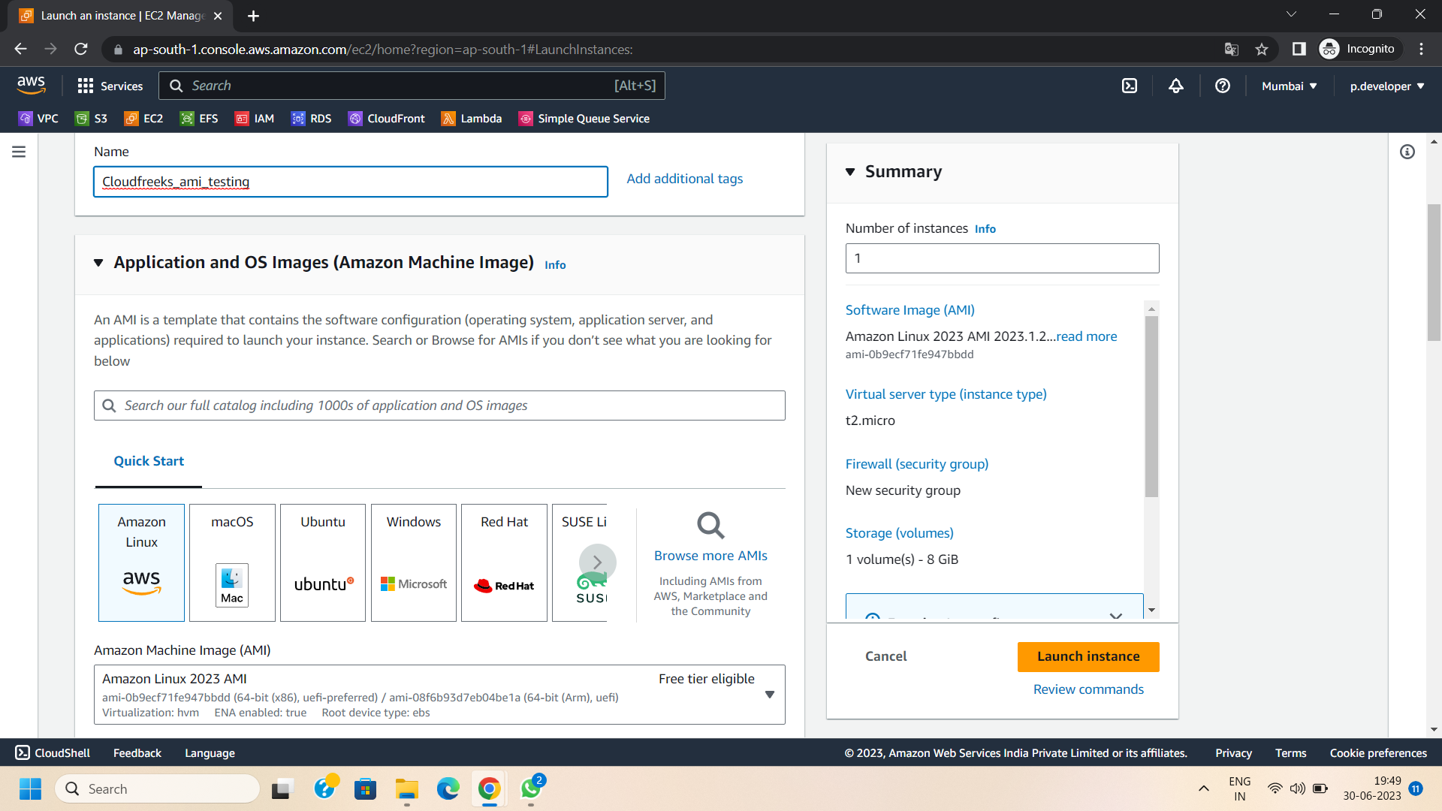

Step 3: After the instance is launched successfully, right Click on the launched EC2 instance and select the “CREATE IMAGE” option.

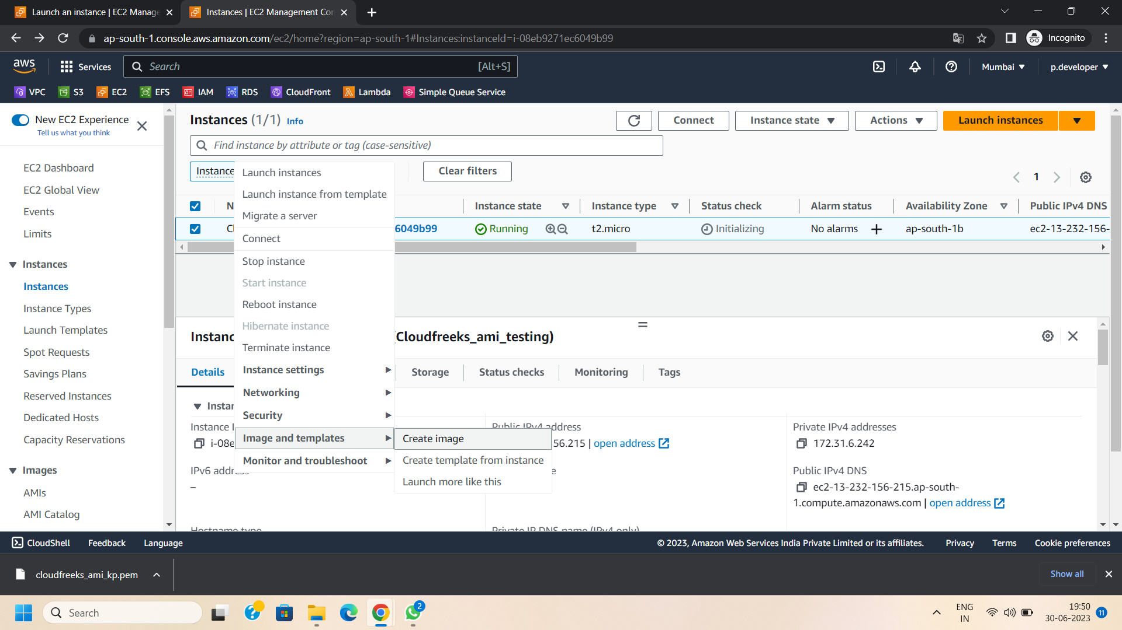

Step 4: Now create image of the selected instance where :

* Enable no reboot
* Enable delete on termination

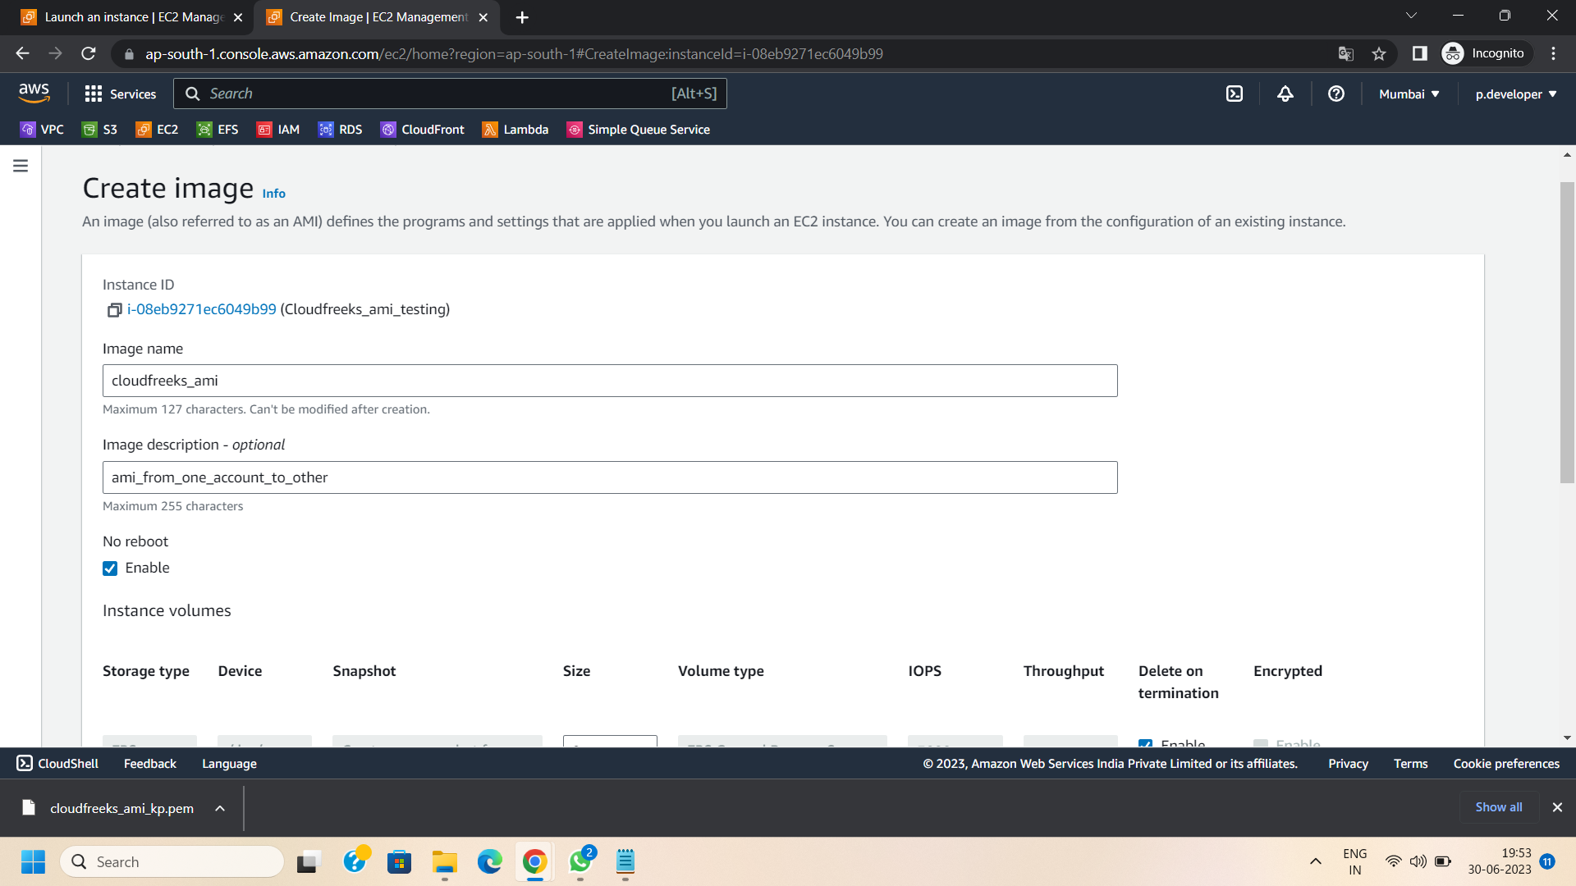

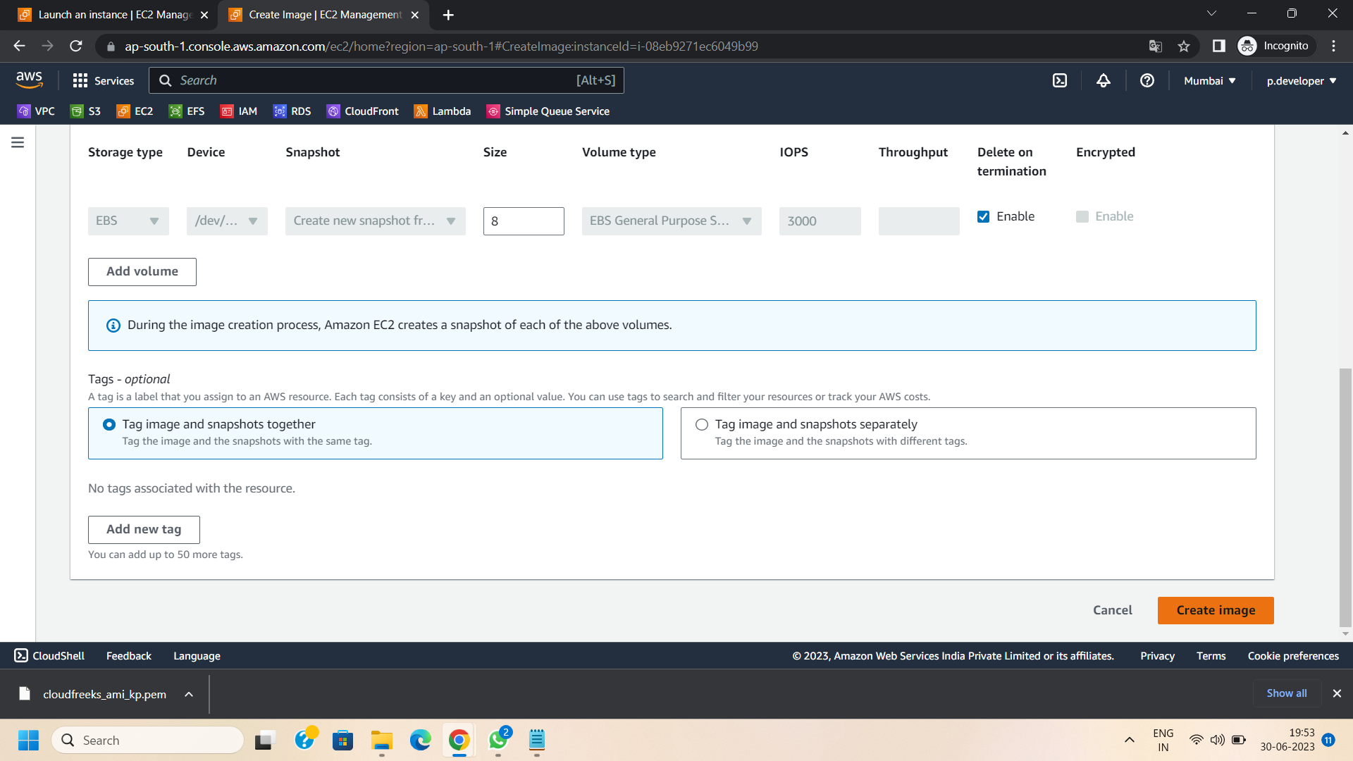

Step 5: Select the created AMI and Click edit permissions

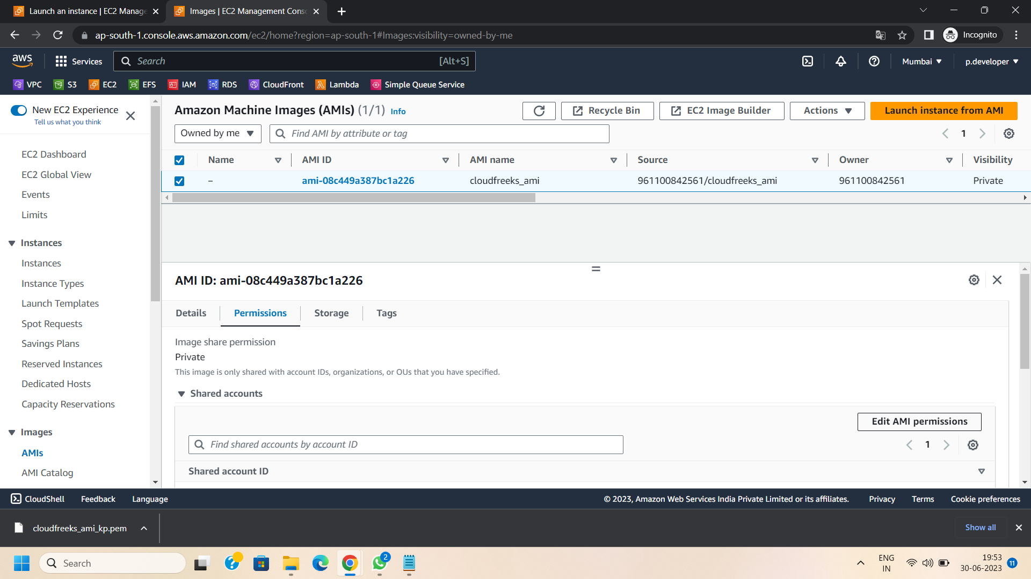

Step 6: Login to the target account in which you want to share your AMI.and Copy its account ID from the profile section.



Step 7: Login back to your first account.

Step 8: In edit AMI permissions

* Check out add ‘create volume’ permissions to associated snapshots when creating account permissions
* Select AMI availability according to your preference(i.e.,Public or private)
* Paste the target account ID (where you want to share your AMI)

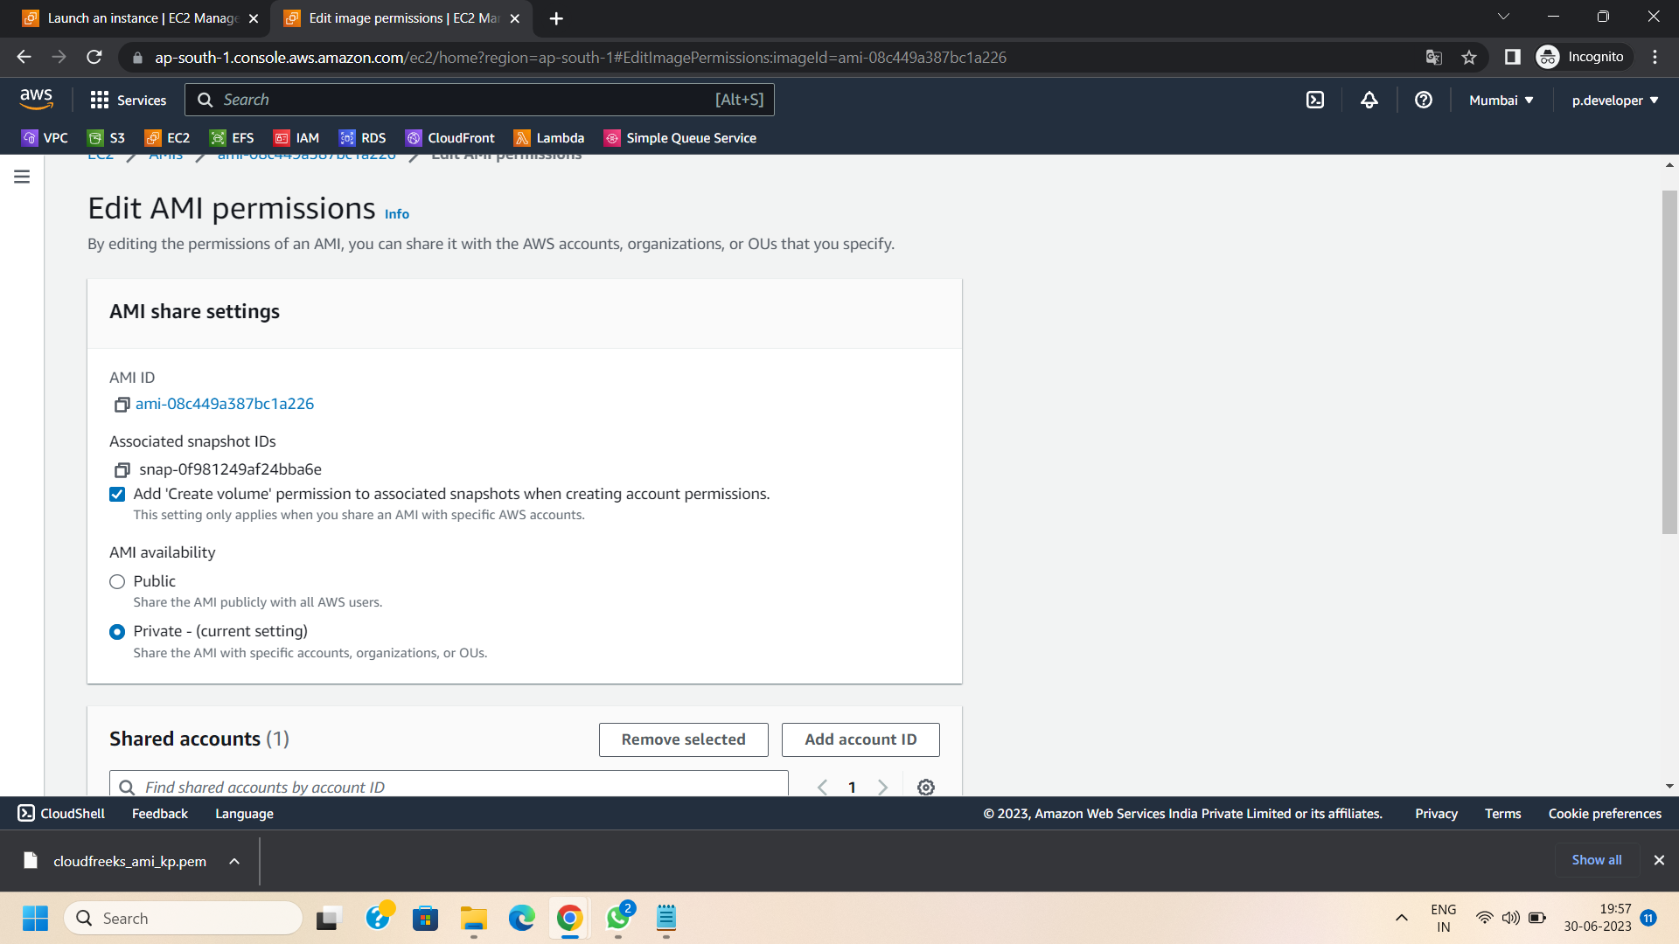

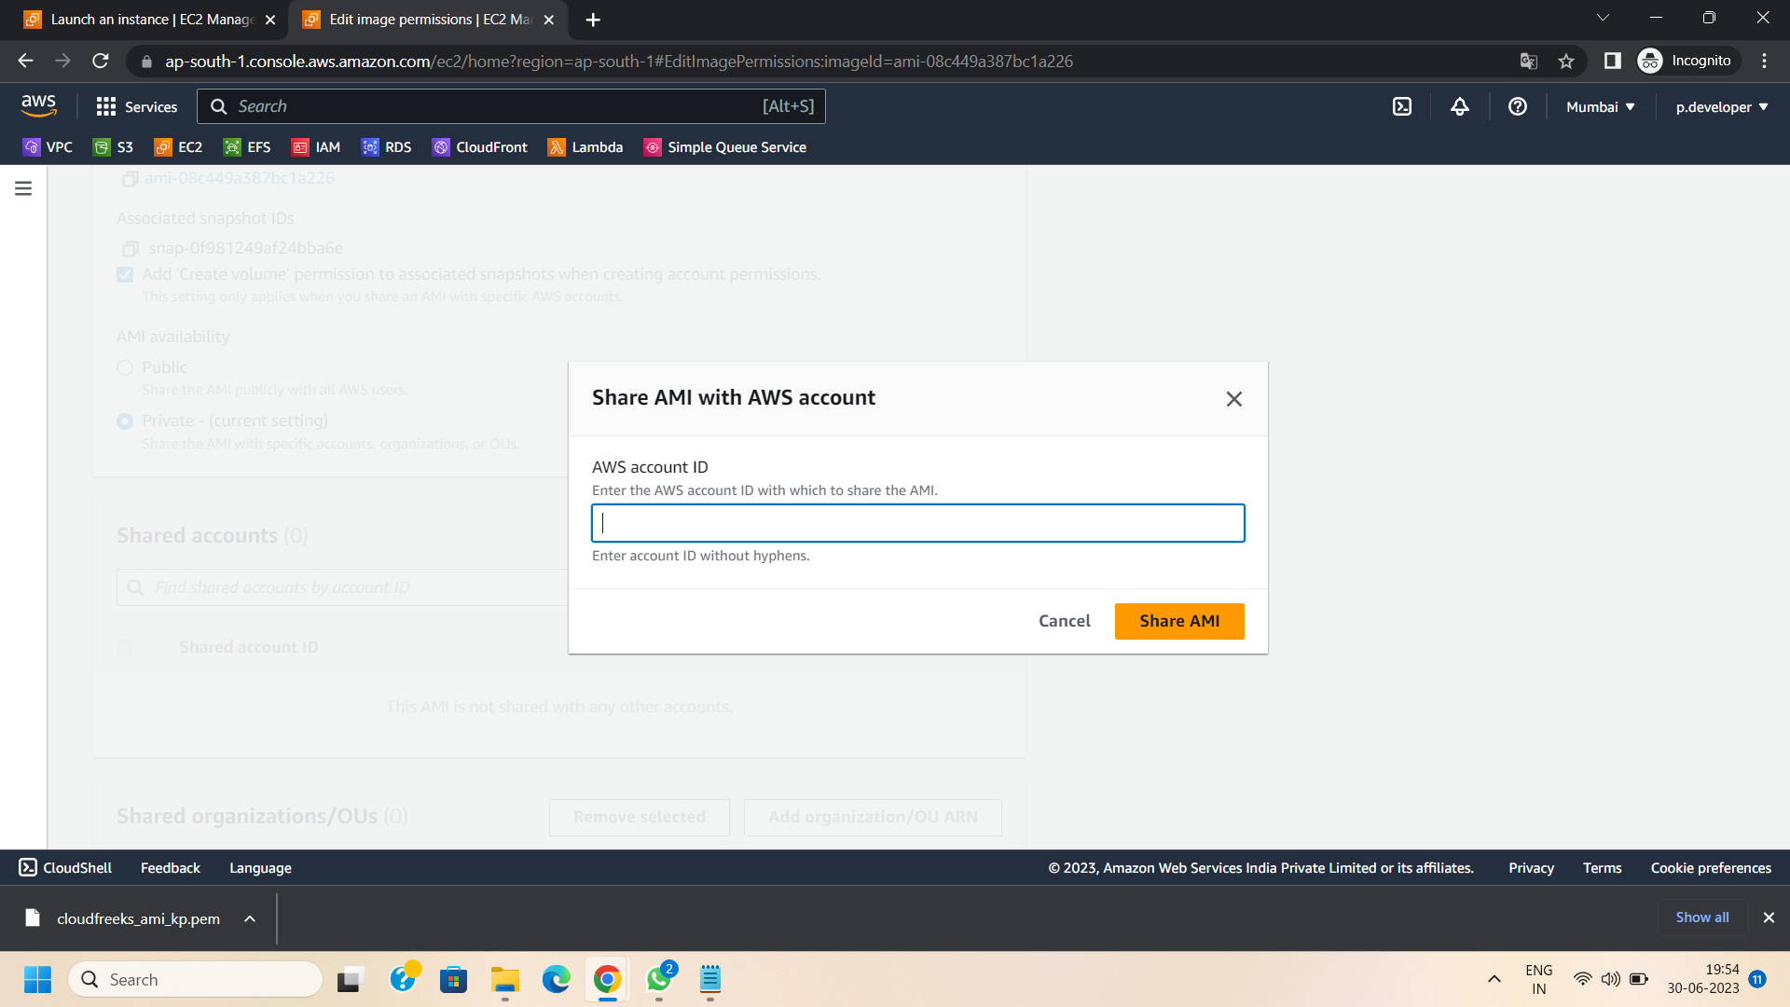

Step 9: Save the modified permissions.

Step 10: Again login to the target account and go to the AMIs and here you see the shared image.

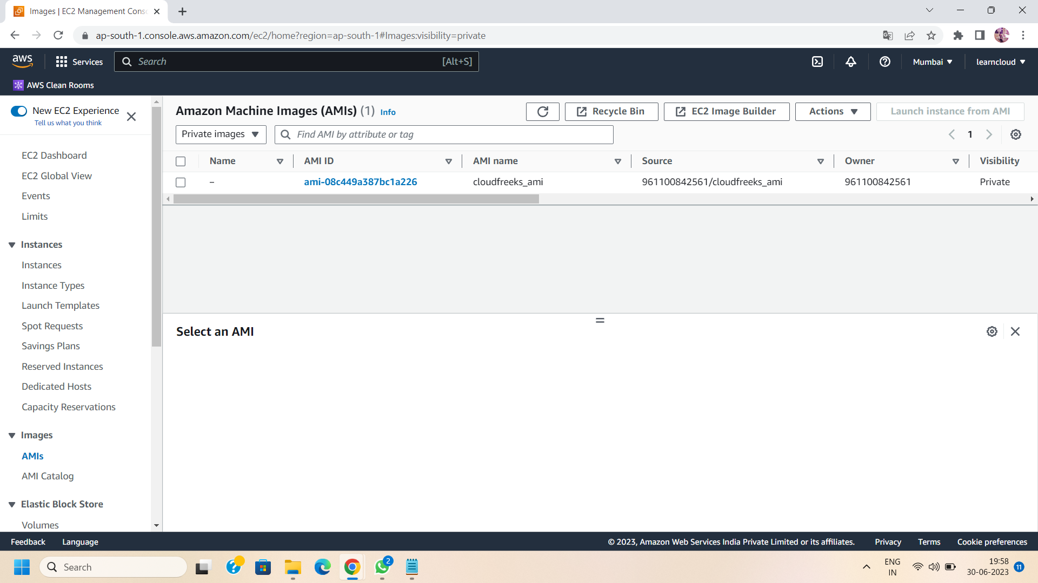

Step 11: Successfully share the image from one account to another.

Step 12: Verify Access in the Recipient Account

Switch to the target AWS account and navigate to the EC2 Dashboard. The shared AMI should now be accessible. From this account, you can launch instances using the shared AMI and leverage its pre-configured settings and software.

Step 13: Now to launch the instance using a shared image in the target account, select the shared AMI and select “launch instance from AMI”.

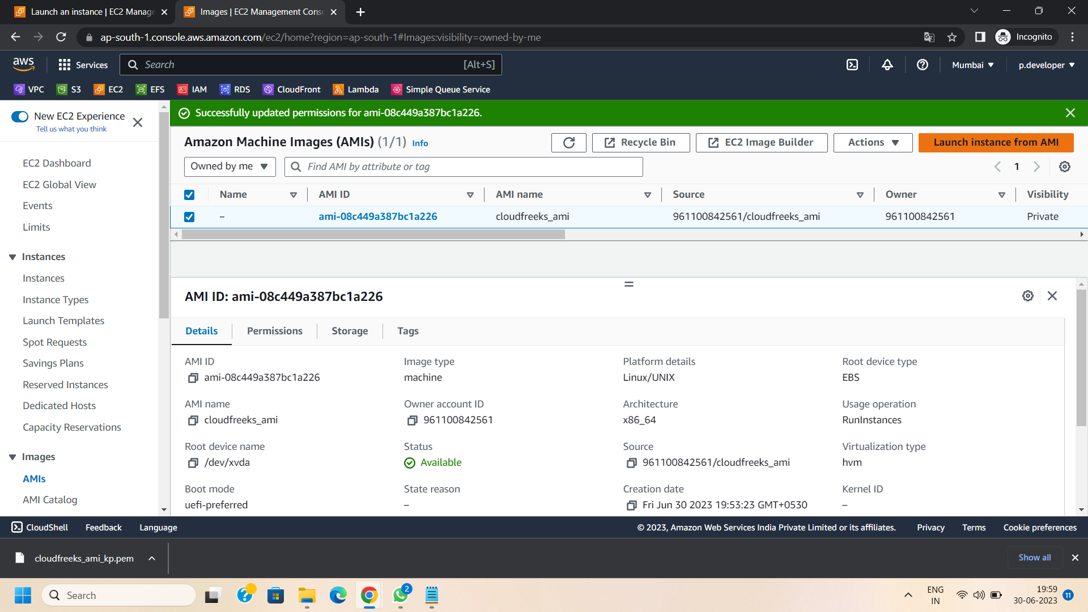

Step 14: Successfully launch the instance from shared AMI.

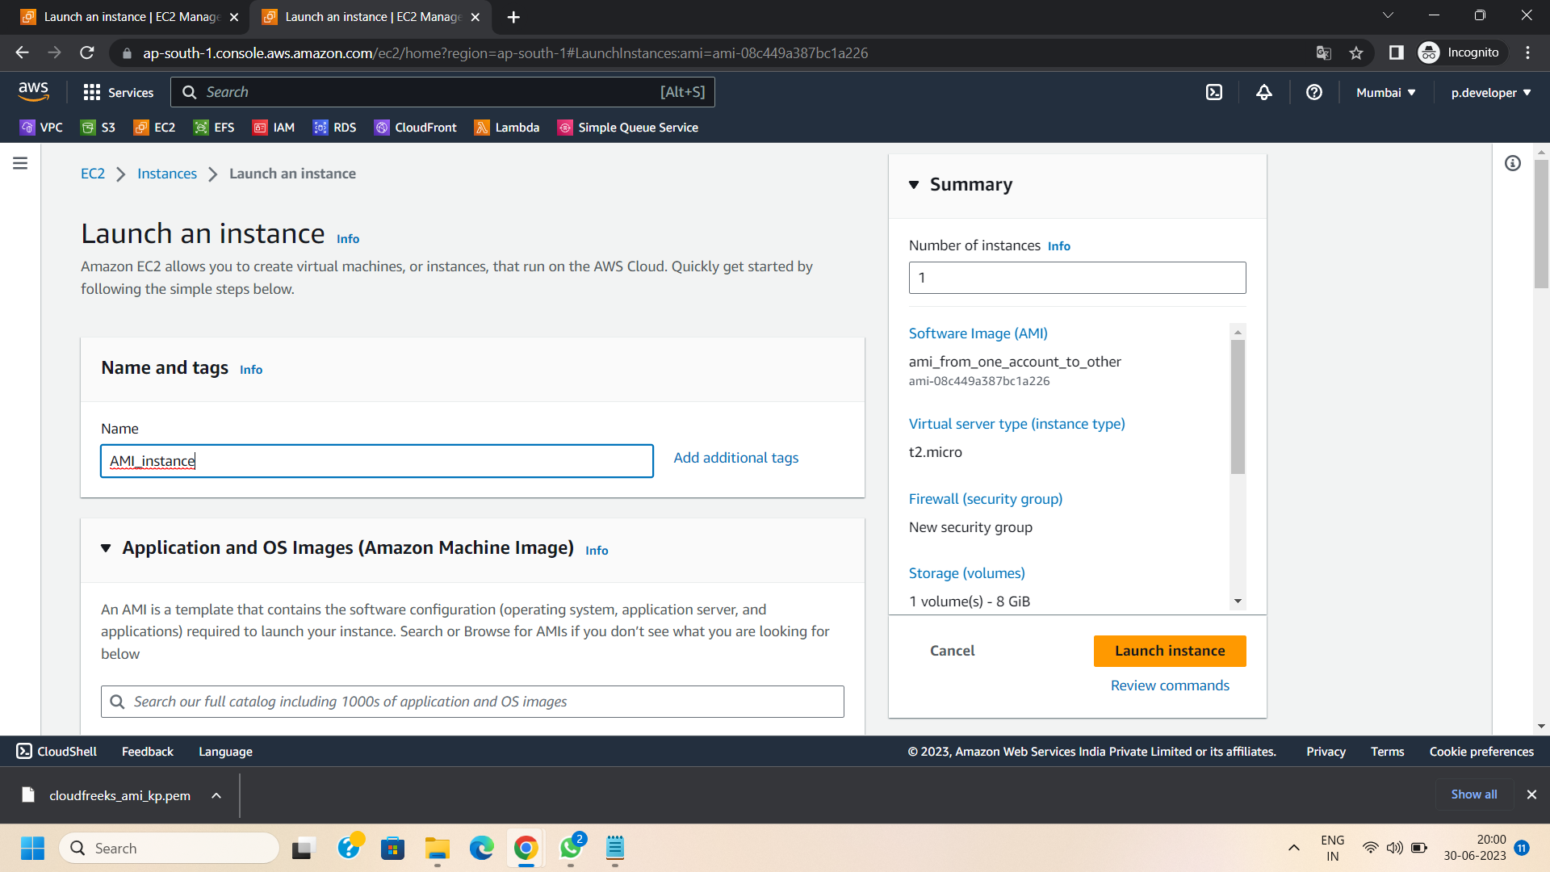

Conclusion:

By following these simple steps, you can easily share an AMI with another AWS account, promoting collaboration and facilitating efficient resource utilization. The ability to share AMIs enhances teamwork, allowing multiple accounts to benefit from pre-configured images and reducing duplication efforts. Embrace the power of shared AMIs to streamline your infrastructure management and accelerate your AWS deployment process. Happy collaborating!